Strategy

Definition
# Source: AI Source: Provided by: [Data Path: Persons Table -> ID Column: 1, Name_En Column: Motasem Essam] -> From: [ChatGPT] on [8/25/2025]
Strategy (as a video game genre) is a type of game where the main focus is on planning, tactics, and decision-making rather than fast reflexes or action. Players must think ahead and manage resources, units, or territories to achieve victory.

Key Features of Strategy Games
# Source: AI Source: Provided by: [Data Path: Persons Table -> ID Column: 1, Name_En Column: Motasem Essam] -> From: [ChatGPT] on [8/25/2025]
- Emphasize thinking over reacting.
- Require resource management, long-term planning, and tactical moves.
- Often involve controlling multiple units or systems.

Main Subgenres of Strategy Games
# Source: AI Source: Provided by: [Data Path: Persons Table -> ID Column: 1, Name_En Column: Motasem Essam] -> From: [ChatGPT] on [8/25/2025]
- Real-Time Strategy (RTS)
  - Description: Base building, resource gathering, and army control in real time.
  - Examples: StarCraft II, Age of Empires II.
- Turn-Based Strategy (TBS)
  - Description: Players take turns to plan and act, focusing on large-scale empire or army control.
  - Examples: Civilization VI, Advance Wars.
- Real-Time Tactics (RTT)
  - Description: Tactical combat in real time; no base building or economy.
  - Examples: Commandos: Behind Enemy Lines, Desperados III.
- Turn-Based Tactics (TBT)
  - Description: Tactical combat in turns; squad-level control, positioning, and cover are key.
  - Examples: XCOM: Enemy Unknown, Fire Emblem, Gears Tactics.
- Grand Strategy
  - Description: Large-scale control of nations or empires: politics, diplomacy, warfare.
  - Examples: Hearts of Iron IV, Europa Universalis IV.
- 4X Strategy
  - Description: Explore, Expand, Exploit, Exterminate; deep empire-building and conquest.
  - Examples: Sid Meier’s Civilization, Stellaris.
- Tower Defense
  - Description: Protect a base by strategically placing defenses against waves of enemies.
  - Examples: Plants vs Zombies, Bloons TD 6.
- MOBA (Multiplayer Online Battle Arena)
  - Description: Real-time team battles controlling single heroes with strategic coordination.
  - Examples: League of Legends, Dota 2.
- Auto Battler (Auto Chess)
  - Description: Place units strategically; battles play out automatically.
  - Examples: Teamfight Tactics, Dota Underlords.
- Card-Based Strategy
  - Description: Deck-building and card mechanics as the main strategic element.
  - Examples: Hearthstone, Slay the Spire.
- Wargames
  - Description: Military-focused strategy, often historical with tactical combat scenarios.
  - Examples: Total War series (mix of RTS and TBS), Panzer Corps.

✅ Core Idea: Success depends on strategy, resource allocation, and foresight, not just quick reactions.

comparison between Real-Time Strategy (RTS) and Turn-Based Strategy (TBS)
# Source: AI Source: Provided by: [Data Path: Persons Table -> ID Column: 1, Name_En Column: Motasem Essam] -> From: [ChatGPT] on [8/25/2025]
Here’s a clear comparison between Real-Time Strategy (RTS) and Turn-Based Strategy (TBS):

✅ Real-Time Strategy (RTS)
- Definition: A strategy game where actions happen continuously, and players must make decisions in real time.
- Gameplay Focus:
  - Base building
  - Resource gathering
  - Army production and control
  - Fast-paced decisions under time pressure
- Player Interaction: Simultaneous – both players act at the same time.
- Examples:
  - StarCraft II
  - Age of Empires II
  - Warcraft III

✅ Turn-Based Strategy (TBS)
- Definition: A strategy game where players take turns, allowing for careful planning without time pressure.
- Gameplay Focus:
  - Territory control
  - Long-term planning
  - Movement in discrete steps (tiles or grids)
- Player Interaction: Sequential – one player moves, then the other.
- Examples:
  - Civilization VI
  - Advance Wars
  - XCOM: Enemy Unknown (although this is more tactical than pure strategy)

✅ Key Differences
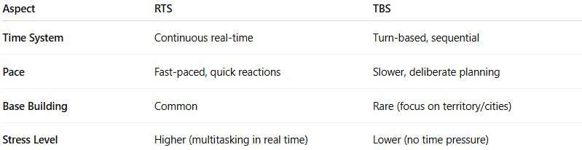
Aspect | RTS | TBS
Time System | Continuous real-time | Turn-based, sequential
Pace | Fast-paced, quick reactions | Slower, deliberate planning
Base Building | Common | Rare (focus on territory/cities)
Stress Level | Higher (multitasking in real time) | Lower (no time pressure)

✅ Summary:
- RTS = Real-time, multitasking, economy + combat.
- TBS = Turn-based, deep planning, no time pressure.

comparison between RTS vs TBS vs RTT vs TBT
# Source: AI Source: Provided by: [Data Path: Persons Table -> ID Column: 1, Name_En Column: Motasem Essam] -> From: [ChatGPT] on [8/25/2025]

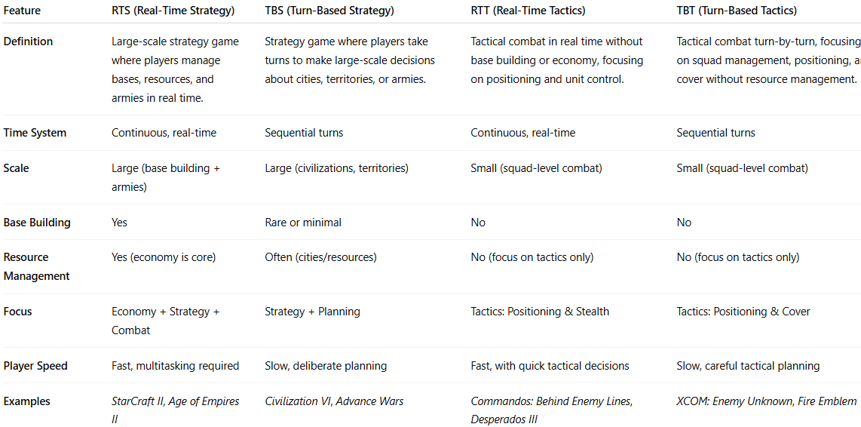
Feature | RTS (Real-Time Strategy) | TBS (Turn-Based Strategy) | RTT (Real-Time Tactics) | TBT (Turn-Based Tactics)
Definition | Large-scale strategy game where players manage bases, resources, and armies in real time. | Strategy game where players take turns to make large-scale decisions about cities, territories, or armies. | Tactical combat in real time without base building or economy, focusing on positioning and unit control. | Tactical combat turn-by-turn, focusing on squad management, positioning, and cover without resource management.
Time System | Continuous, real-time | Sequential turns | Continuous, real-time | Sequential turns
Scale | Large (base building + armies) | Large (civilizations, territories) | Small (squad-level combat) | Small (squad-level combat)
Base Building | Yes | Rare or minimal | No | No
Resource Management | Yes (economy is core) | Often (cities/resources) | No (focus on tactics only) | No (focus on tactics only)
Focus | Economy + Strategy + Combat | Strategy + Planning | Tactics: Positioning & Stealth | Tactics: Positioning & Cover
Player Speed | Fast, multitasking required | Slow, deliberate planning | Fast, with quick tactical decisions | Slow, careful tactical planning
Examples | StarCraft II, Age of Empires II | Civilization VI, Advance Wars | Commandos: Behind Enemy Lines, Desperados III | XCOM: Enemy Unknown, Fire Emblem

